A.BABU
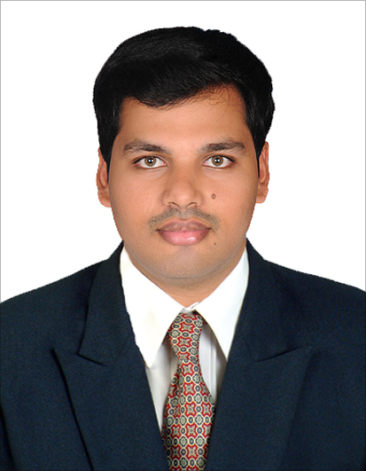
GF-B, Barani flats,
No.25,Warners road, cantonment,
Trichy-620001.
Mail : babu21891@gmail.com
Mobile No : 9894399092, 8122181991

CAREER OBJECTIVE :
Seeking for a challenging position as a Civil Engineer, where I can use my planning, designing and overseeing skills in construction and work towards the success of esteem organization.
ACADEMIC PERFORMER :
Qualification | Institution | Board/university | Year of passing | Percentage (%)
B.E  (CIVIL) | CARE School Of Engineering | Anna University Chennai | 2013 | 67
HSC | Campion Anglo Indian H.S.C School, Trichy | State Board | 2009 | 79
SSLC | Campion Anglo Indian H.S.C School, Trichy | Anglo Indian Board | 2007 | 80

AREAS OF INTEREST :
- Construction Project Management
- Construction Safety Engineer
- Designer
EXTRA AND CO-CURRICULAR ACTIVITIES :
- Participated in Many Cultural and Sports activities in Schools and Colleges.
- Attended several department related Workshops and Presented papers in Technical
Symposium.
- Student Representative, Placement cell at CARE School of Engineering, Trichy
- President of Science Club (2009-2013) at CARE school of engineering.
- Team Leader, Final year civil engineering project at CARE school of engineering.
- N.C.C candidate.
PROJECT DETAILS :
Mini Project:
- Analysing and finding solution to Traffic Problems in and around Singarathope, W.B Road, Trichy.
- Bio-Medical Waste Management at Hospitals in Trichy.
Main Project:
Artificial Ground Water Recharge Management by RAIN WATER HARVESTING at Manarupuram area, Trichy
EXPERIENCE :
As a Management Trainee in Real Estate and Management at SAAMY PROPERTY DEVELOPERS, from 1st May 2013 - Till present.
PERSONAL DETAILS :
Name | : | A.Babu
Father’s Name | : | S.Arun
D.O.B | : | 21st August 1991
Marital Status | : | Single
Nationality | : | Indian
Languages known | : | English, Tamil, French
Strengths | : | Firm belief in God, Sincerity, Leadership, Self Motivated, Innovative & Hard Working, Good in Teamwork, Eager to learn new things.
Software skills | : | Photoshop, MS office, Auto-CADD (2D & 3D),REVIT Architecture.

DECLARATION :
I hereby declare that the information furnished above is true to the best of my knowledge.

Place : Trichy
Date :
(A.BABU)

